**CS-213: Advanced Programming**

**Class: BSCS 7AB**

**Lab 08: React JS**

**Name: Muhammad Hannan**

**BSCS 7B**

**207873**

**Task1:**

**App.js**

import React, { Component } from "react";

import "./App.css";

import Greet from "./Greet";

class App extends Component {

constructor(props) {

super(props);

}

render() {

return (

<div>

<h1>This is task 1</h1>

<Greet name="Hannan" hobby="cricket">

<p>This is the child tag in the Greet Component</p>

</Greet>

</div>

);

}

}

export default App;

**Greet.js:**

import React, { Component } from "react";

import "./App.css";

class Greet extends Component {

constructor(props) {

super(props);

this.state = { message: "click", count: 0 };

}

render() {

return (

<div>

<h1>

Welcome {this.props.name},who loves {this.props.hobby}{" "}

</h1>

<h3> No of times button clicked:{this.state.count} </h3>

<h3>Click the button to toggle between click and unclick</h3>

<button onClick={() => this.changeMessage()}>

{this.state.message}

</button>

<br />

{this.props.children}

</div>

);

}

increment() {

this.setState(

{

count: this.state.count + 1

},

() => {

console.log("call back value", this.state.count);

}

);

console.log(this.state.count);

}

changeMessage() {

this.increment();

if (this.state.message == "click") {

this.setState({ message: "unclick" });

console.log("clicked to unclicked");

} else {

this.setState({ message: "click" });

}

}

}

export default Greet

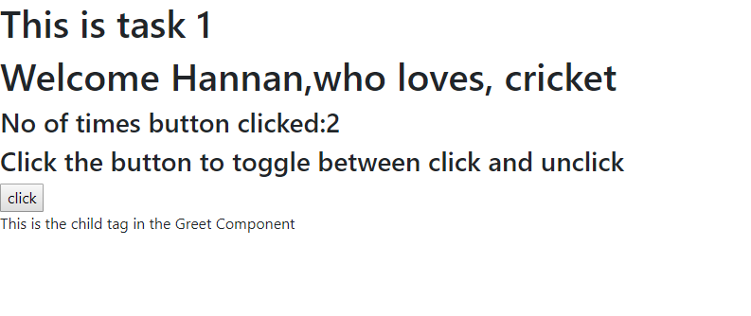

**TASK 2:**

**import React, { Component } from "react";**

**import "./App.css";**

**class Timer extends Component {**

**render() {**

**return (**

**<div>**

**<h1>**

**{this.props.minutes}:{this.props.seconds}{" "}**

**</h1>**

**</div>**

**);**

**}**

**}**

**class App extends Component {**

**constructor(props) {**

**super(props);**

**this.state = {**

**seconds: "00",**

**minutes: "00"**

**};**

**this.time = 0;**

**this.intervalHander = 0;**

**this.handleChange = this.handleChange.bind(this);**

**this.startCountDown = this.startCountDown.bind(this);**

**this.changeTime = this.changeTime.bind(this);**

**}**

**handleChange(event) {**

**this.setState(**

**{**

**minutes: event.target.value**

**},**

**() => {**

**console.log(this.state.minutes);**

**}**

**);**

**}**

**changeTime() {**

**if (this.time === 0) {**

**console.log("hii");**

**document.getElementById("input").style.display = "block";**

**document.getElementById("button").style.display = "block";**

**document.getElementById("input").style.marginLeft = "600px";**

**document.getElementById("button").style.marginLeft = "650px";**

**clearInterval(this.intervalHandler);**

**}**

**console.log("time" + this.time);**

**var min = Math.floor(this.time / 60); // convert to minutes**

**console.log("minutes: " + min);**

**var sec = this.time % 60;**

**console.log("start count down");**

**if (min < 10 && sec < 10) {**

**this.setState({**

**minutes: "0" + min,**

**seconds: "0" + sec**

**});**

**} else if (sec < 10) {**

**this.setState({**

**minutes: min,**

**seconds: "0" + sec**

**});**

**} else if (min < 10) {**

**this.setState({**

**minutes: "0" + min,**

**seconds: sec**

**});**

**} else {**

**this.setState({**

**minutes: min,**

**seconds: sec**

**});**

**}**

**this.time--;**

**}**

**startCountDown() {**

**this.time = this.state.minutes * 60;**

**this.intervalHandler = setInterval(this.changeTime, 1000);**

**document.getElementById("input").style.display = "none";**

**document.getElementById("button").style.display = "none";**

**console.log("start count down");**

**}**

**render() {**

**return (**

**<div className="App">**

**<h1> Timer </h1>**

**<input id="input" type="number" onChange={this.handleChange} required />**

**<Timer minutes={this.state.minutes} seconds={this.state.seconds} />**

**<button id="button" onClick={this.startCountDown}>**

**Start**

**</button>**

**</div>**

**);**

**}**

**}**

**export default App;**

